OPERATION MANUAL

DIGITAL pH MONITOR

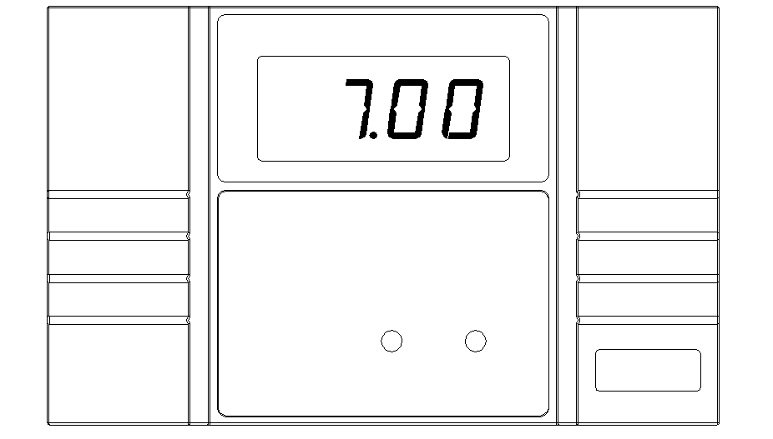

Before putting the pH monitor to use, please check the local power voltage, and read this manual carefully.

FRONT & BACK PANEL DESCRIPTION
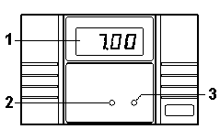 | 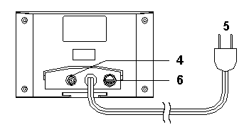

1) pH display
2) pH4 adjustment knob
3) pH7 adjustment knob
4) pH electrode BNC input terminal
5) Power cord with plug
6) Fuse

OPERATING (CALIBRATION)
1) Connecting AC power supply. (Make sure the correct voltage.)
2) Connecting the pH electrode into the pH input terminal socket. (in back side)
3) Put the pH electrode into the standard buffer solution pH7.00. Waiting for a few seconds and adjust the "pH7" knob until the display reading exact 7.00.
4) Take away the pH electrode from buffer solution, and clean the electrode with fresh water.
5) Put the pH electrode into the standard buffer solution pH4.00. Waiting for a few seconds and adjust the "pH4" knob until the display reading exact 4.00. (You also can calibrate pH10.00. Use the buffer solution pH10.00 instead of pH4.00 buffer solution.)
6) Take away the pH electrode from buffer solution, and clean the electrode with fresh water.
7) Put the pH electrode into the water what you want to measure.
When use a new pH electrode, user has to repeat step 1) to 7) for calibrating when put a new pH electrode to use.
CLEANING AND MAINTENANCE
1) It must to pull out the power plug (turn off) when cleaning the controller.
2) Please wipe the housing with drying when cleaning, do not wipe with wetting.
3) It had better to calibrate the pH electrode during 3-6 weeks to make sure the reading within accuracy when measuring in a long time.
 pH electrode input BNC terminal should plug in pH electrode only.
Please use this pH monitor away from the electronic ballast

SPECIFICATION
Measurement：pH：0 to 14 pH
Accuracy at 25℃：±(0.1%+ 2 digits) after calibrating
Impedance：1012 ohms
Calibration Knob：External pH7 (CAL.) and pH4 / pH10(SLOPE)
Display：pH 0.56" LED, 3 ¹/₂ digits
Operating Temperature：0 to 50℃ (32 to 122℉)
Operating Humidity：Max. 90%
Power Supply：Please refer to back side of instrument.
(AC100V, AC110V, AC220V, AC240V indicator when order)
Power Consumption：Approx. 2 watts
Dimension：165 x 105 x 65mm ( 6.5 x 4.1 x 2.6 inch)
Standard Accessories：cover*1, holder*1, metal bracket*1, adjusting sticker*1, ORP probe*1, black bracket*1

使用說明書

pH 監測器

使用本控制器前, 請詳讀本說明書及注意當地電壓

面板說明

1) pH 值
2) pH4 調整鍵
3) pH7 調整鍵
4) pH電極輸入端子
5) 電源插頭
6) 保險絲

操作(校正)
1) 連接到交流電源供應。 (注意為正確的電壓).
2) 將pH電極插入機器背面孔 BNC 端子
4) 將pH電極放入標準校正液pH7.00中. 等待數秒及調整"pH7" 鍵直到顯示板上的值出現7.00
5) 將標準校正液pH7.00拿走. 用清水將電極洗淨.
6) 將PH電極放入標準校正液pH4.00中. 等待數秒及調整"pH4" 鍵直到顯示板上的值出現4.00. (亦可使用標準液pH10 校正 pH10.00 代替標準校正液pH4)
7) 將標準校正液pH7.00拿走. 用清水將電極洗淨. (當使用新電極, 務必執行步驟1~7.)
8) 將pH電極放入欲測量之水中進行測量。

清潔與保養
1) 開始清潔前務必將關掉電源
2) 以乾布擦試機器, 切勿使用溼布
3) 建議每3-6星期校正PH電極一次以確保所測值之精準度.

pH 電極輸入BNC 端只供插入pH電極用
使用時請遠離電子安定器

規格
範圍：pH：0 to 14 pH
解析度：pH ：0.01 pH
精準：±(0.1%+ 2位數) 於25℃ 校正後
阻抗：1012 ohms
校正鈕：外部 pH7 (CAL.) and pH4 / pH10 (SLOPE)
螢幕：pH 0.56" LED, 3 ¹/₂ digits
運作溫度：0 to 50℃ (32 to 122℉)
運作濕度:最大 90%
電源供應:依產品標籤所示. 訂購時請註明所需電壓
電力消耗: 最大2瓦
規格：165 x 105 x 65mm ( 6.5 x 4.1 x 2.6 inch)
標準配備: 主機*1, 上蓋*1, 底座*1, 掛勾*1, 調整棒*1, 電極支架*1, PH電極*1

